|  |
| --- |
| CS590BD Big Data Analytics and Applications |
| Lab 3 Assignment |
| Goutham Marikanti  16171450 |

TASK 1

# Implement an application to generate a file showing any four of the given activities.

* Import the project from Blackboard and run it on your machine with slight modifications based on the activities you want to run.
* I chose the following activities:
* Accelerometer
* GPS
* Gyroscope
* Date and Time

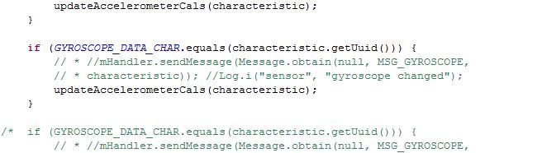

* Then run the application on your Android device.
* Turn the Sensor Tag ‘ON’ and move it around to make the values change.
* The following file will be generated on your android device.

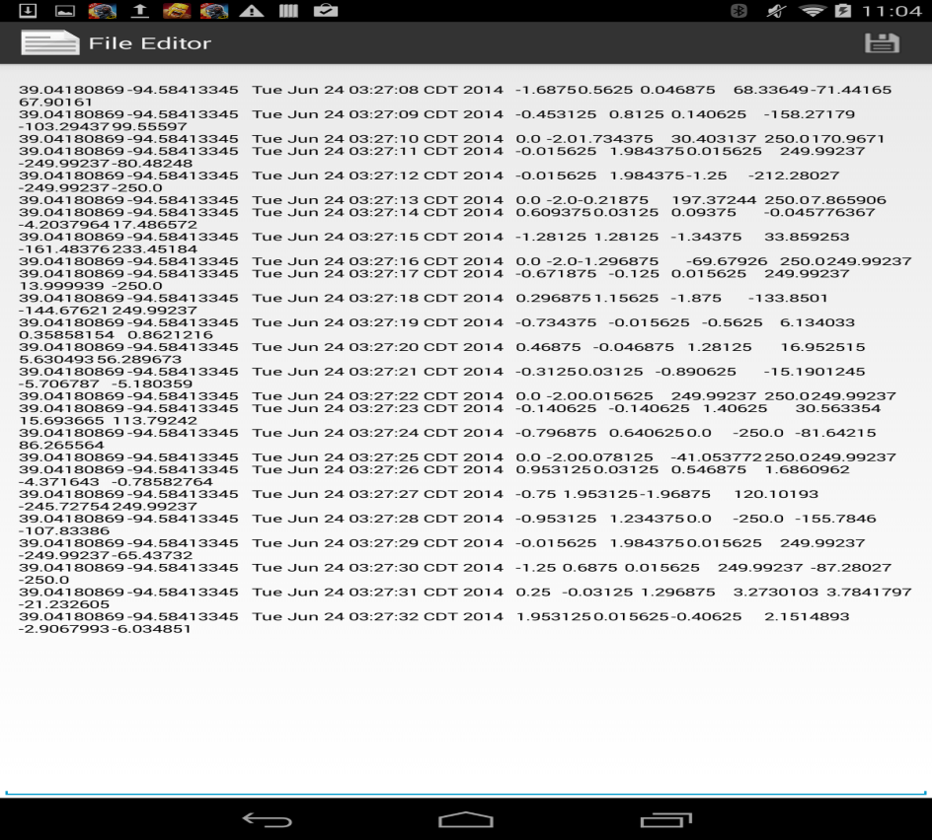

* You can download “Astro File Manager ” to browse your Android device and find this file.

TASK 2

# Develop an application to transfer the file to Cloudera

* Run the given code as below to connect and retrieve uncommenting the respective functions :

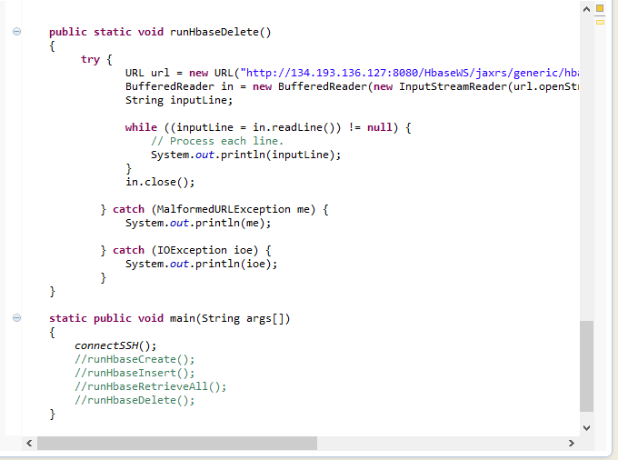

* Generate a War file for the project and deploy it on GlassFish Server.

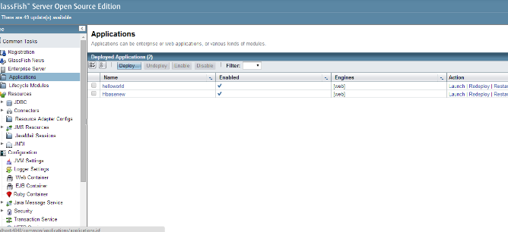

TASK 3

# Implement an application to execute HBase CRUD operations

Using the Android app we are calling web services to ‘Create’, ’Insert’, ‘Retrieve’ and ‘Delete’ the table.

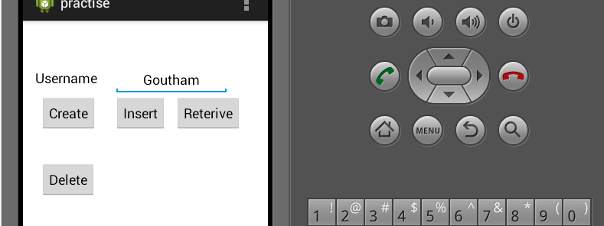

* Creating Table in Hbase

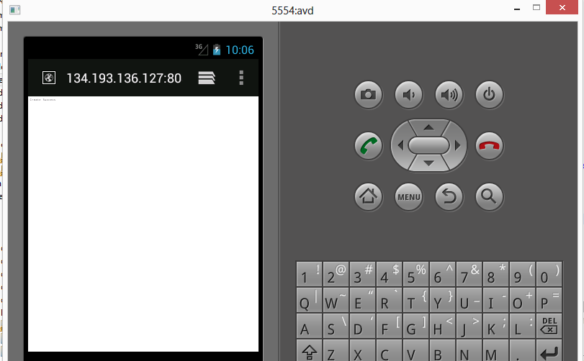

* Inserting (sensor.txt) file into hbase



* Reteriving contents from table

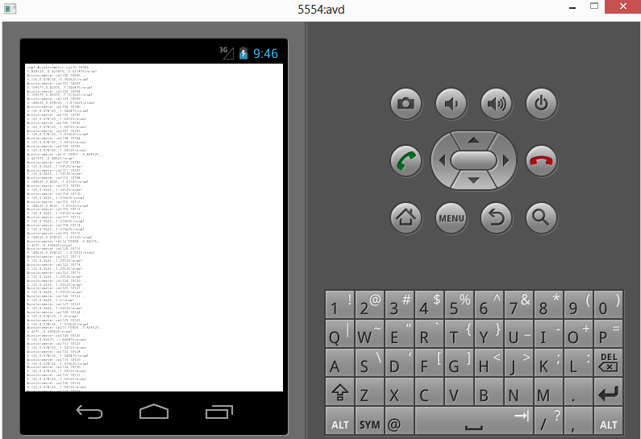

* Deleting Table from Hbase

